
ORDER FORM
Name of School: |  |  |  | Name of nominated contact:
E-mail address for electronic resources to be sent to (nominated contact):
Contact name and email address for invoicing and method of payment including PO number if applicable:
Please place an ‘X’ for products required
& remarks/comments e.g. Indicate year groups if whole school package not required
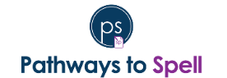 |  |  | 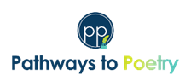 |  |  | 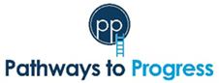
THEMED UNITS ONLY  This does not include access to the platform | 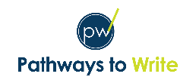 | ☐Single age  ☐Mixed-age | ☐Honouring Stories  ☐SMSC  ☐Environment  ☐Shakepeare | ☐ Whole-school themed set (EY-Y6)  ☐Other (please specify):
 | 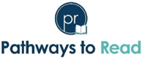 |  | ☐Well-being  ☐Fiction  ☐Non-fiction | ☐ Whole-school themed set (Y1-Y6)  ☐Other (please specify):
To purchase platform packages of Pathways to Write or Pathways to Read, please complete our online order form by clicking here.
Terms and conditions of the purchase of Pathways Literacy products, including Pathways to Write, Pathways to Read, Pathways to Poetry, Pathways to Spell and Pathways to Progress:
All materials and property relating to Pathways Literacy are wholly owned by The Literacy Company Ltd. Unauthorised use of all materials, distribution of materials, or republication without prior written approval of The Literacy Company Ltd, is strictly prohibited. This includes all Literacy Company materials purchased by any school via a third-party provider. The names and logos of Pathways Literacy remain the property of The Literacy Company Ltd and may not be used without prior written approval. As all resources are electronic, we cannot process any exchanges or refunds once the resources have been issued. View the full terms and conditions: https://www.theliteracycompany.co.uk/terms-and-conditions/
Name of School:
Signature (I accept the conditions above):
Date: Click or tap to enter a date.
When do you intend to implement the programme(s) in school?: Click or tap to enter a date.
How did you hear about us? Choose an item.
Referral code (if applicable):
Price List
Pathways to Poetry |  | Pathways to Spell |  | Pathways to Progress
Full Package EYFS-Y6 | £300 | Full package (Y1-Y6) | £395 | Cost Year 1 |  | Ongoing access to subject knowledge videos – annual subscription
Single Year Group (6 units) | £45 | KS1 package (Y1-Y2) | £180 | Full Package Y1-Y6 | £1295 | £200
Individual Poetry unit | £7.50 | KS2 package (Y3-Y6) | £315 | KS1 only (Y1, Y2) | £495 | £75
 |  | Single year group | £115 | KS2 only (Y3-Y6) | £945 | £140
 |  |  |  | Single Year Group | £275 | £40
Pathways to Write (themed units) |  | Pathways to Read (themed units)
Themed Set (Honouring Stories, SMSC, Environment, or Shakespeare) EYFS-Y6 | £250 | Themed Set (Fiction, Non-Fiction, or Well-Being) Y1-Y6 | £250
Individual unit | £40 | Individual unit | £40
This does not include access to the platform

All prices are subject to VAT
To purchase platform packages of Pathways to Write or Pathways to Read, please complete our online order form by clicking here.

